## Mini-Project: Analysis

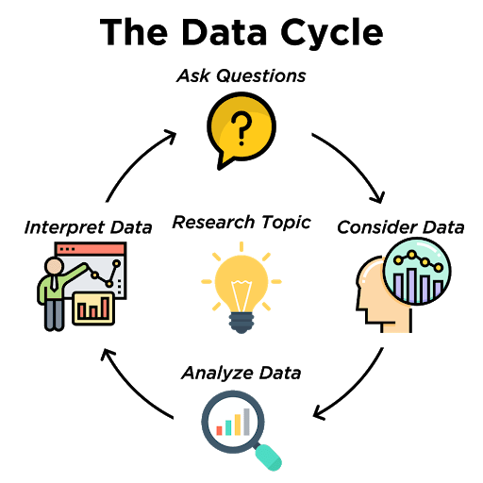

Copy over your code and data from the previous Mini-Project exercise. In this activity, you will complete the data science life cycle by analyzing and interpreting what you have discovered.

* *Analyze Data*: Perform statistical analysis, run calculations and/or create data displays to identify patterns and relationships
* *Interpret Data*: Answer questions and summarize the results.

**Requirements:**

You should explore and include one or more of the following analysis techniques:

* Perform statistical analysis such as the mean, median, standard deviation, etc.
* Run calculations by using a function and creating a new column with the results of the calculations.

**Task:**

1. Explore and perform analysis on your data.
2. Interpret the results and print a conclusion statement.